[*Open in app [](https://rsci.app.link/?%24canonical_url=https%3A%2F%2Fmedium.com%2Fp%2F1e442376218b&%7Efeature=LiOpenInAppButton&%7Echannel=ShowPostUnderUser&source=---top_nav_layout_nav----------------------------------)*](https://rsci.app.link/?%24canonical_url=https%3A%2F%2Fmedium.com%2Fp%2F1e442376218b&%7Efeature=LiOpenInAppButton&%7Echannel=ShowPostUnderUser&source=---top_nav_layout_nav----------------------------------)

*[](https://medium.com/me/notifications?source=---top_nav_layout_nav----------------------------------)*



*Search*



A simple overview on Machine Learning

[*Sayemuzzaman*](https://sayemuzzamansiam.medium.com/?source=post_page---byline--1e442376218b--------------------------------)



*3 min read · 4 days ago*

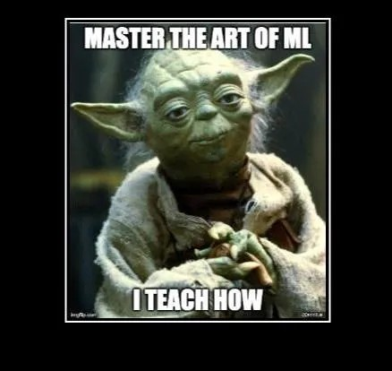



[*Listen*](https://medium.com/plans?dimension=post_audio_button&postId=1e442376218b&source=upgrade_membership---post_audio_button----------------------------------)



*Share*

*More*

𝗪𝐡𝐚𝐭 𝐢𝐬 𝐌𝐚𝐜𝐡𝐢𝐧𝐞 𝐋𝐞𝐚𝐫𝐧𝐢𝐧𝐠 ***?***

At its core, machine learning (ML) is about teaching machines to learn from data and improve their performance over the time without being explicitly programmed. This is achieved through algorithms that identify patterns in data and use those patterns to make predictions or decisions.

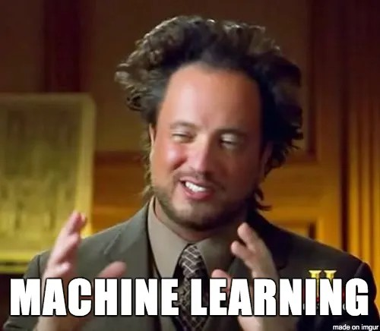

𝐊𝐞𝐲 𝐄𝐥𝐞𝐦𝐞𝐧𝐭𝐬 𝐨𝐟 𝐌𝐚𝐜𝐡𝐢𝐧𝐞 𝐋𝐞𝐚𝐫𝐧𝐢𝐧𝐠

These are the fundamental building blocks that define how machine learning works:

1. *Data*
   1. : The raw material for machine learning.
   2. : Can be structured (e.g., tables) or unstructured (e.g., images, text).
   3. : Includes input data (features) and output data (labels/targets).
2. *Algorithms*
   1. : Mathematical procedures or rules that analyze data to identify patterns.
   2. : Examples: Linear Regression, Decision Trees, Neural Networks.
3. *Models*
   1. : The output of training an algorithm on data.

Represents the learned patterns and can be used to make predictions on new data.

1. *Evaluation*
   1. : The process of assessing how well a model performs.
   2. : Uses metrics like accuracy, precision, recall, or mean squared error..

𝐊𝐞𝐲 𝐂𝐨𝐦𝐩𝐨𝐧𝐞𝐧𝐭𝐬 𝐨𝐟 𝐌𝐚𝐜𝐡𝐢𝐧𝐞 𝐋𝐞𝐚𝐫𝐧𝐢𝐧𝐠

These are the functional parts that make up the machine learning workflow:

1. *Datasets*
   1. : Collections of data used for training, testing, and validation.

Split into training data (to teach the model) and test data (to evaluate it).

1. *Features and Feature Engineering*
   1. : Features: The input variables used by the model to make predictions.
   2. : Feature Engineering: The process of selecting, transforming, or creating features to improve model performance.
2. *Model Training*
   1. : The process of feeding data into an algorithm to learn patterns. Involves adjusting model parameters to minimize errors.
3. *Evaluation Metrics*
   1. : Quantitative measures used to assess model performance. Examples: Accuracy, F1-score, ROC-AUC, Mean Absolute Error (MAE).



𝐇𝐨𝐰 𝐈𝐭 𝐀𝐥𝐥 𝐅𝐢𝐭𝐬 𝐓𝐨𝐠𝐞𝐭𝐡𝐞𝐫

1. Start with Data: Collect and prepare the dataset (e.g., clean, preprocess, split into training and testing sets).
2. Choose an Algorithm: Select an appropriate algorithm based on the problem (e.g., classification, regression).
3. Train the Model: Use the training data to teach the algorithm to recognize patterns.
4. Evaluate the Model: Test the model on unseen data to measure its performance using evaluation metrics.
5. Iterate and Improve: Refine the model by tuning hyperparameters, engineering better features, or using more data.

𝐓𝐫𝐞𝐞 𝐟𝐨𝐫𝐦𝐚𝐭𝐢𝐨𝐧

*Machine Learning*

***├──*** Key Elements

*│ ├── Data*

*│ ├── Algorithms*

*│ ├── Models*

*│ └── Evaluation*

***└──*** Key Components

*├── Datasets*

*├── Features and Feature Engineering*

*├── Model Training*

*└── Evaluation Metrics*

**

***Not today, next time***

[*Machine Learning*](https://medium.com/tag/machine-learning?source=post_page-----1e442376218b--------------------------------)

[*Algorithms*](https://medium.com/tag/algorithms?source=post_page-----1e442376218b--------------------------------)

[*ML*](https://medium.com/tag/ml?source=post_page-----1e442376218b--------------------------------)



[*Edit profile*](https://medium.com/me/settings/account?source=post_page---post_author_info--1e442376218b--------------------------------&profileInformation)

[*Written by Sayemuzzaman*](https://sayemuzzamansiam.medium.com/?source=post_page---post_author_info--1e442376218b--------------------------------)

[*1 Follower*](https://sayemuzzamansiam.medium.com/followers?source=post_page---post_author_info--1e442376218b--------------------------------) *·* [*14 Following*](https://sayemuzzamansiam.medium.com/following?source=post_page---post_author_info--1e442376218b--------------------------------)